USER’S MANUAL

SP-SA2IB+
Mini Digital Amplifier with EQ and Mixer

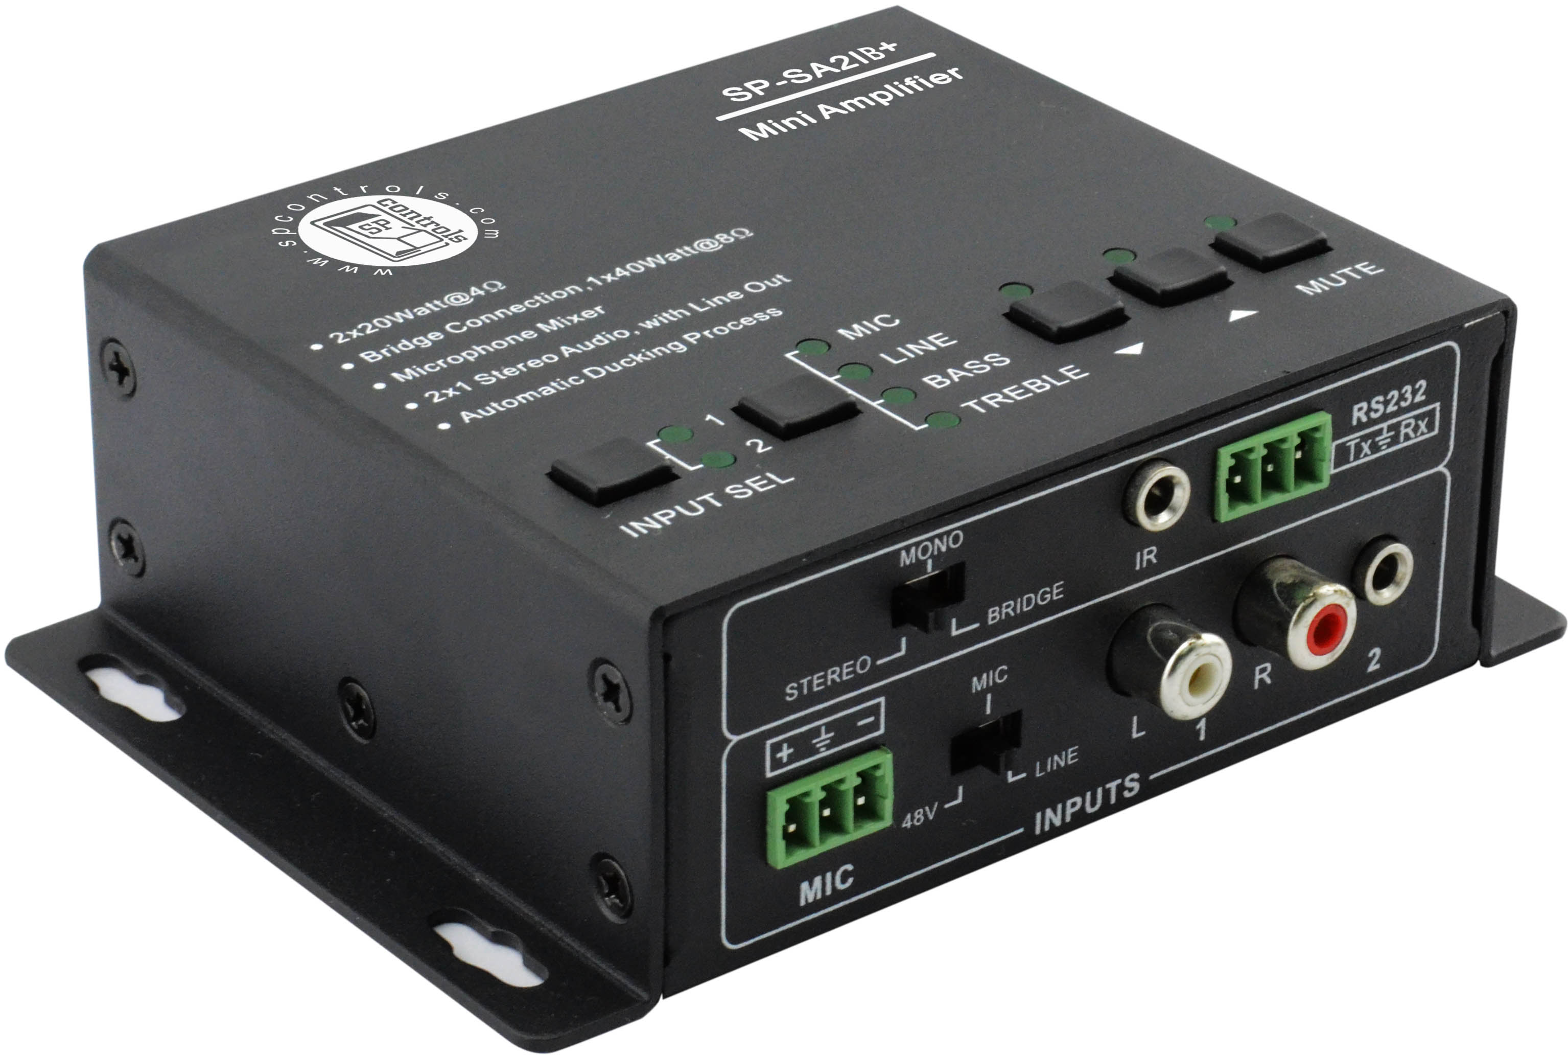
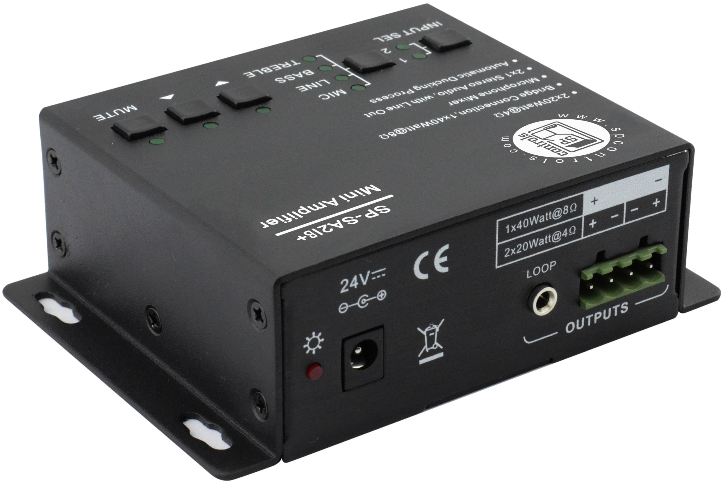

Table of Contents
1. Introduction 3
2. Features 3
3. Specifications 4
4. Audio Connection 5
5. Buttons Controls 7
6. RS232 Communication Protocol 9
7. System Diagram 11
8. Panel Drawing 12

Introduction
SP-SA2IB+ is a compact-size digital amplifier (Class-D) with 3 inputs (2 line in and 1 balanced MIC). It is integrated with powerful functions, including bridge connection, dual-mono, EQ control, microphone mixer etc., making it an ideal amplifier for the classroom, small meeting room, or lecture hall.

Features
- Two stereo audio inputs, switchable by button, IR remote, or RS232.
- Volume/Bass/Treble controllable by buttons, IR remote, or RS232.
- 2x20Watt @ 4Ohm as the default amplifier output.
- Line audio output, volume controllable.
- Bridge connection function: The user can switch the SP-SA2IB+ to be 1x40Watt @ 8Ohm by bridge connection.
- Dual-mono function: The output can be configured to mono on both channels for equal distribution.
- MIC mixer function: The microphone will be mixed to the line audio output, and separately controllable.
- MIC input supports 48V phantom power, dynamic MIC and wireless MIC.
- MIC port can support balanced/unbalanced signal to suppress the external noise effectively.
- Auto noise gate continually detects the audio and MIC input, and mutes the output when there are no inputs detected.
- No need for power sequencing with the ultra low inrush current. This allows multiple SP-SA2IB+ amplifiers to be powered on simultaneously without overloading power circuits.
- Convection cooler—fan is not needed.
- Antistatic case design provides protection for long-term and stable performance.
- LED indicator for power and working status.

Specifications

Audio Input |  | Audio Output
Input | 2 stereo audio,  1 MIC | Output | 1 amplifier,  1 stereo audio
Input Connector | 2 RCA  1 3.5mm jack  1 captive screw connector | Output Connector | 1 captive screw connector  1 3.5mm jack
Input Impedance | >10KΩ | Output Impedance | 50Ω/stereo, 4~8Ω/Amplifier
Audio General
Frequency Response | 20Hz ~ 20KHz | CMRR | >70dB@20Hz~20KHz
SNR | 80dB at maximum output | Bandwidth | 20Hz ~ 25KHz
Stereo Channel Separation | >75dB@20Hz to 20KHz | THD + Noise | 1%@1KHz, 0.3%@20KHz  at nominal level
Voltage Gain | 32dB | Power Output | 2 x 20 Watts (4 Ohms)
Control Function
RS232 Control | RS-232, 9-pin female D connector | Pin Configurations | 2 = TX, 3 = RX, 5 = GND
IR Remote | Optional IR remote
NOTE: All nominal levels are at ±10%.

Audio Connection
4.1 Audio Output
4.1.1 Default output: 2x20Watt@4Ohm
The default output of amplifier is 2x20Watt@4Ohm, so user can connect the amplifier output in the regular way. As the picture below:
Switching to the “STEREO”
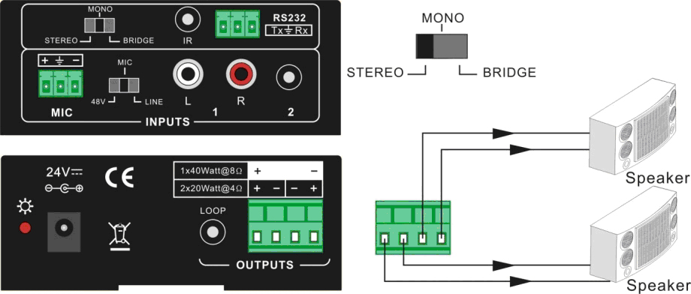
Connecting the four pins

4.1.2 Bridge connection: 1x40Watt@8Ohm
The SP-SA2IB+ has the bridge connection to double the output power at 1x40Watt@8Ohm. It will sum up the input left channel and input right channel to be mono output, and the power is up to 40Watt. The bridge connection is shown here:
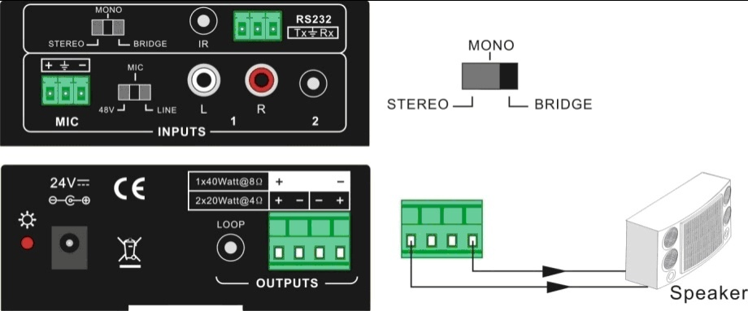
Switching to the “BRIDGE”
Connecting the two pins

4.1.3 Dual-mono output:
The SP-SA2IB+ also has the function of double-mono output. It can sum up the left and right channel to be the mono audio output. In this configuration, both of the outputs are showing the same mono audio.
The connection is:
Switching to the “MONO”
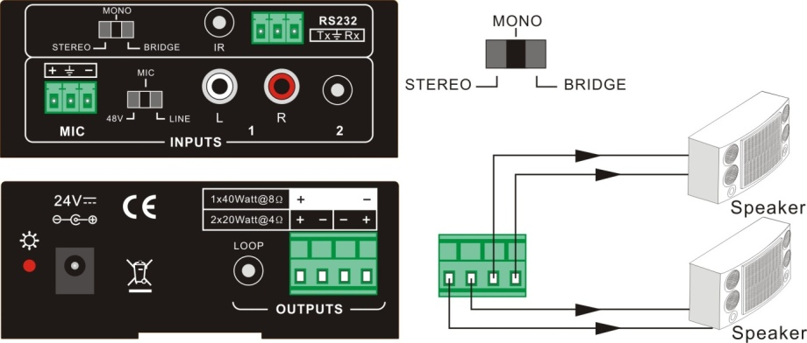
Connecting the four pins

4.2 Microphone input
The microphone input of SP-SA2IB+ has three modes, and different modes use different connections as shown.
Input modes switch.
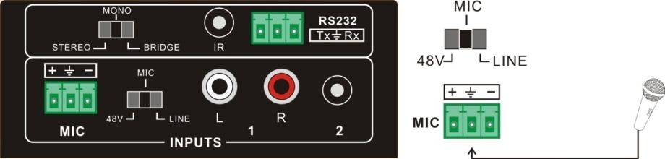
    - 48V phantom power input
When the switch turns to “48V”, the MIC input will provide a 48V phantom power. This is usually used for the power supply for the condenser microphone. Connection is:
“+” connects to positive, “-” connects to negative and “╧” to ground.
NOTE: In this mode, only a condenser microphone can be connected.

    - MIC input
When the switch turns to “MIC”, the microphone input is used for connecting a dynamic microphone. There are two different connections:

- Unbalanced connection:
- “╧” connects to ground, and “-” connects to signal.
- “╧” connects to ground, and “+” connects to signal.
- Balanced connection: “+” connects to positive, “-” connects to negative and “╧” connects to ground.
    - LINE input
When the switch turns to “LINE”, the microphone input is used for connecting with normal audio or wireless microphone output. There are two different connections:
- Unbalanced connection:
- “╧” connects to ground, and “-” connects to signal.
- “╧” connects to ground, and “+” connects to signal.
- Balanced connection: “+” connects to positive, “-” connects to negative and “╧” connects to ground.

Button Controls
The buttons provides the control of volume/EQ control and switching.
5.1 Audio switching
There are two switchable stereo audio inputs, one 2xRCA input, and one 3.5mm jack input, switchable through the buttons as shown below:
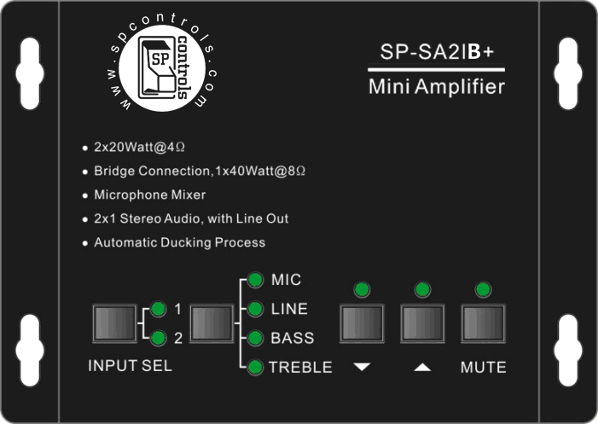
Source Selection

5.2 Volume/EQ controlling
The line volume and MIC volume can be controlled by the buttons.
The MIC Volume/LINE Volume/LINE Bass/LINE Treble will be selected by the buttons, and controlled Up/Down/Mute by the function buttons as shown below:
First select the function from this menu.
Then turn the level up, down or mute.

For example, to turn up the line volume you should select the “LINE” first, and then press the button “ ”.

RS232 Communication Protocol

Baud rate: 9600 Data bit: 8 Stop bit: 1 Parity bit: none
Command | Function Description | Feedback Code
1A1. | Switching the Audio to Input 1 | A: 1 -> 1
2A1. | Switching the Audio to Input 2 | A: 2 -> 1
0A0. | Mute Audio of MIC and Line Out | Mute Audio
1A0. | Mute Audio of MIC | Mute MIC
2A0. | Mute Audio of Line Out | Mute LIN
0A1. | Unmute Audio | Unmute Audio
600% | Checking the working status | A: 1 -> 1  Volume: 30  Bass: 00  Treble: 00
601% | MIC Volume Up | Volume of MIC: 51
602% | MIC Volume Down | Volume of MIC: 51
603% | Line Volume Up | Volume of LINE: 51
604% | Line Volume Down | Volume of LINE: 51
605% | Bass Level Up | Bass of LINE: 04
606% | Bass Level Down | Bass of LINE: 04
607% | Treble Level Up | Treble of LINE: 04
608% | Treble Level Down | Treble of LINE: 04
609% | Initialization, back to the default setting | A: 1 -> 1  Volume: 50  Bass: 04  Treble: 04

Command | Function Description | Feedback Code
5[x][x]% | Preset MIC volume, [xx] range from [00] to [60].  61 degrees in total. | Volume of MIC: 50
7[x][x]% | Preset line volume, [xx] range from [00] to [60].  61 degrees in total. | Volume of LINE: 50
8[x][x]% | Preset the bass level, [xx] range from [00] to [08].  9 degrees in total. | Bass of LINE: 04
9[x][x]% | Preset the treble level, [xx] range from [00] to [08].  9 degrees in total. | Treble of LINE: 04

Note:
1: The letter inside bracket [ ] is the variable code, which is the changeable.
2: The bracket [ ] is not included to the RS232 commands.
3: Any dot “.” after the letters is part of the commands.

Example 1:
Switching the input 2 to the line out, send the RS232 command: [2A1.]
Example 2:
Turning up the volume of line audio, send the RS232 command: [603%]
Example 3:
Preset the MIC volume to “21” degrees, send the RS232 command: [521%]
Example 4:
Checking the working status of SP-SA2IB+, send the RS232 command: [600%]

System Diagram

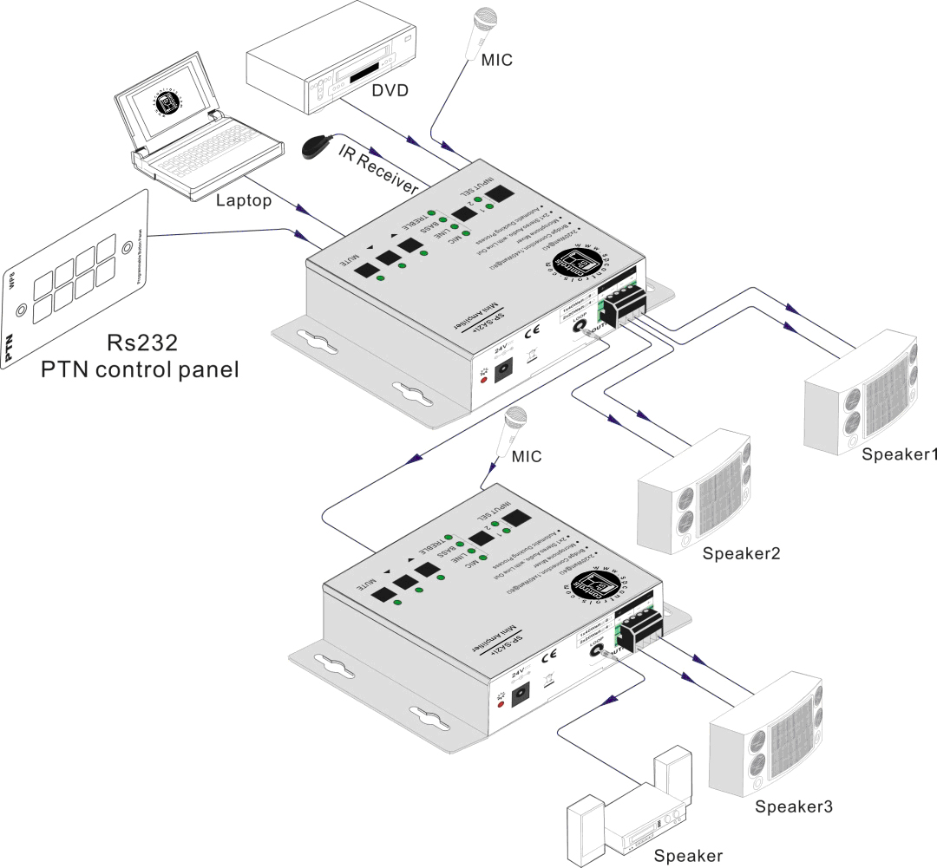
2x20Watt@4Ohm
Looping connection
1x40Watt@8Ohm

Panel Drawing
